Viewing and Parsing Instructions – ON-LINE version

Adapted from original instructions devised by Phil Barnard and Tony Marcel for the Viewing and Parsing Exercise, Choreography and Cognition/ Phase II [http://www.choreocog.net]

In this study we are going to show you a number of short video clips of four different individuals moving. We are interested in what is in these sequences. What are they sequences of? In order to be as neutral as possible, we shall just refer to what might be in these sequences using the general term units.

There will be two phases. First we are going to ask you to watch all the sequences on the computer screen. We will also show you how to use the simple controls on the video player. This phase is likely to take around ten minutes or so. In the second phase we shall ask you to work through each of the sequences in turn. In this phase you will be reminded about how to use the controls and how to record your units. This phase will obviously take more time than the first!. Please read through all of these instructions carefully now – they will be available to you throughout if you need to check something later.

Phase 1: There are eight video-clips, and they last between half a minute and two minutes. All you need do in this phase is observe the individuals moving and get an overall feel for what is going on in the full set of material we have. There will be plenty of time in Phase 2 to look at each one more extensively.

Phase 2: This is where we want you to work in detail on what is in the sequences. We are not asking you to name, characterise or describe what is there. We are simply asking you to try to indicate at what points a unit starts and ends. It is entirely up to you to decide what a unit is. Of course, you may see the whole sequence as just one indivisible unit. If you do you are perfectly free to indicate this. But we would ask you to try to be more analytic than that. In other words, if you had to divide it up into units where would they be? In this phase you will go through each of the eight sequences in turn.

What you have available: The viewing and parsing tool:

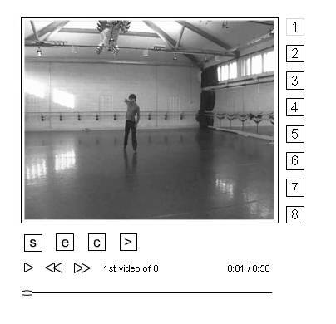

At the right of the video window are numbers corresponding to the eight video clips/ sequences. Click on these to change between clips. At the bottom, below the video window, you see a time line with a scroll bar that you can drag back and forth to reposition the video playhead. Above that are familiar arrows that allow you to watch the sequence in real time and to pause the action (the left single arrow) and to jump forward and back one second in the clip use the second two double arrows (or the left and right buttons on your keyboard). You also see a number indicating which video sequence you are watching, and you can also see to the right the time in seconds for each frame (where you are in the total length). The S button allows you to insert a marker across the time line as the START of a unit, the E insert a marker as the END of a unit. You can also reposition the S and E markers by clicking and dragging the along the time line. C allows you to CLEAR all unit markers (be careful because you clear them all using C) and the > (this is the SUBMIT button) is for when you complete the exercise of viewing and parsing all eight clips. It records and submits all of your unit markers automatically into a response form and takes you to a final comment box. Please do not use this option until you have finished your viewing and parsing.

What to do:

For each sequence you should first look at the whole sequence by playing it at normal speed. You can then play it again either at normal speed or pausing, going back and forth by dragging the scroll bar or clicking on the double arrows (or using the left and right buttons on your keyboard) just like on a video recorder. You should then, on the third run-through, begin to try to mark your units using the S and E buttons mentioned above. When you do this, obviously you can start and stop the sequence and move it backwards and forwards wherever and whenever you need to. You can also reposition the S and E markers by clicking and dragging them along the time line. When you have finished with one sequence and are satisfied perhaps make some notes on paper or in another software window (word processor or text editor) you wish to enter into comment box at the end.

Once you have finished going through identifying the units to the end of a particular sequence – play the whole sequence once more to make sure you are happy with what you have done. You can then proceed to the next video clip/ sequence by clicking on the buttons (1-8) running along the left side of the video window. Please work through the other seven in the order given from top to bottom.

Remember it is really important to understand that there are no "correct" or "wrong" answers, types of units, or starts and ends - we just want to know what you see as units in these sequences. Also don’t agonise over individual decisions, and don’t spend ages worrying over the “exact” start/end point. Try to work as fast as you feel comfortable with. If you want to comment on specific aspects of the sequence or indeed about anything in general, then make a note number in the seventh column and write the same note number with the substance of your comment in the notebook. Again there is no need to make notes or comments, that too is up to you.

Results/ Followup:

We do not know if individuals who visit this site will commit to completing this on-line version of the Viewing and Parsing Exercise (the dancers who participated in January 2004 took an afternoon to parse all eight clips). It is our plan to conduct the experiment using this on-line version in more controlled circumstances with some selected groups of individuals sometime in the near future.

However, if you DO take the time to read these instructions and would be interested to complete this exercise and to see how your results compare with the original experiment and/ or others who complete this on-line version, please send an email to Scott deLahunta (sdela@ahk.nl) for further information.

