PrincipAl components analysis of contemporary dance kinematics

K.Hollands¹, A.M.Wing², A.Daffertshofer³
¹School of Health Sciences, University of Birmingham, UK
²School of Psychology, University of Birmingham, UK
³ Faculty of Human Movement Sciences, Vrije Universiteit, Amsterdam, NL

k.hollands@bham.ac.uk, a.m.wing@bham.ac.uk, marlow@fbw.vu.nl

Abstract – Principal components analysis was used to identify invariant or common features within the whole body kinematics of a contemporary dance movement pattern. A small number of components were sufficient to describe most of the relevant signal (variability). Similar components were consistently identified over different repetitions performed by the same dancer as well as across dancers.

I. INTRODUCTION

Highly variable human movement may contain features or regularities that simplify the description of movement and provide insight into motor control principles. However, the kinematics of individual body segments during complex movement patterns exhibit a great deal of subject- and context- dependent variability that are not easily analysed using conventional event identification techniques. Recently, investigators have begun to apply factor analysis techniques such as, Principal Components Analysis (PCA), to kinematic and electromyographic (EMG) measures of human movement. PCA is an algorithm that attempts to extract a small number of components that sufficiently describe the total variation in the original variables[1].
To date, PCA has been applied to kinematic and EMG data from locomotion, which is a very stereotyped movement pattern. The technique has not yet been extended to complex, idiosyncratic, whole body movements involved in other every day activities or in expressive performance. The presence of common components across different activities might yield valuable insights into styles of control across the entire spectrum of the human movement repertoire.
The goal of the present research was to investigate the use of PCA to identify invariant, or common, movement components within contemporary dance movement patterns as part of a project on how the central nervous system (CNS) use controls the execution of complex sequential movements. To do this we applied PCA on the kinematics of a contemporary dance movement pattern performed several times by two trained dancers.

II. METHODS

A 15s movement phrase of contemporary dance choreography was created and performed several times by one dancer (D1, male) and subsequently performed several times by a second dancer (D2, female) from a professional dance company.
The first dancer was instructed to create a movement phrase by defining 3 self-selected reference points in space around the body and then weave a series of movements in and around these points in such a way that both hands passed repeatedly through the reference points. The paths of the hands between points varied from curved trajectories to straight trajectories resulting in a movement phrase incorporating whole body translations, required by the positioning of the dancer’s reference points, as well as more ornamental whole body rotations and twisting, and rotations of the hands and arms. Once the first dancer was content with the movement phrase he had created, he was asked to reproduce it 6 times without further change. He then taught the second dancer the phrase and, once she was confident she had memorised the sequence, she reproduced it 6 times. The phrase was created and performed in silence.
The kinematics of the movements were measured using a six-camera, Vicon 3D motion analysis system (Oxford Metrics) with a 32 marker whole body set-up sampled at 120 Hz. Markers were placed on the following anatomical landmarks; forehead, temples, acromio-clavicular joints, upper arms, elbows, forearms, wrists, C7, sternal notch, xyphoid process, ASISs, PSISs, thighs, knees, tibias, lateral malleoli, calcanei and the base of the 2nd metatarsals.

III. RESULTS

Kinematic data comprising x,y,z positions of each of the 32 markers (see Fig 1) were normalized to unit variance and time normalized before PCA was performed. Normalizing
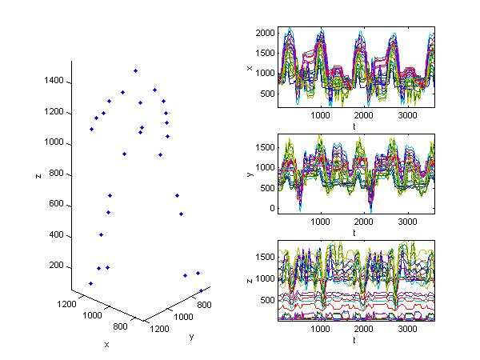

Figure 1: Raw traces of whole body kinematic data from 32 markers in three dimensions (96 signals) for two consecutive performances of a movement phrase by dancer D1.

to unit variance prevents segments with the largest amplitude of movement, in this case the arms and feet, from dominating the identified components [1].
A small number of principal components were sufficient to describe most of the relevant signal variability. The component describing the largest portion of the signal was found to be associated with translation of all the body markers on a diagonal in the xy plane. This component was therefore identified with a large diagonal step and reach with the right hand. The second and third largest components were found to represent vertical (z) movement of the centre of mass through knee bending and coupled arm movements in the medial/lateral (x) directions respectively.
Figure 2: PCA of whole body kinematic data for the first two performances of the movement phrase by dancer D1. The eigenvalues are shown (left) on a logarithmic scale. After mode 9 there is a sharp drop in the eigenvalues, which indicates that only 9 modes are necessary to represent the main features of the data. Indeed over 82% of the variance (signal) in the original data is recovered when the first 3 projections (middle) are multiplied by the 96-d eigenvectors (right).

Figure 3: PCA of whole body kinematic data for first two performances by dancer D2 of the same phrase produced by dancer D1 (see Fig 2).

The remaining modes may be interpreted as random variation, slow drift of variables such as the centre of mass [1], or, in this instance, artistic license and individual performers’ motion signatures [2].
Within a dancer, the same components were consistently identified across repetitions. Between dancers, similarities in terms of form and frequency, were seen in several of the components. For example, component 1 is similar in Figs 2 and 3 once the double sign reversal of projection and eigenvector is taken into account, and component 3 has a similar periodicity in each case. Moreover, these components each account for numerically similar proportion of variance in the two dancers’ data sets.

III. CONCLUSION

In gait analysis PCA has yielded insight into walking strategies and interrelationships in terms of temporal, kinematic and kinetic variables [3,4]. PCA can be used to study the entire temporal gait pattern and can detect differences due to disease that would have been difficult to interpret from the original data set [5]. The present study is the first to investigate the value of PCA as a tool for investigating motor control principles of complex expressive whole body movement patterns. Our results show that, much like kinematic and EMG data of locomotion, kinematics of complex and novel movement patterns can also be reduced to a small number of components that describe the majority of the original signal and are consistent within and, to some degree, across individuals.
Our results indicate that kinematic data from complex movements are suitable for PCA. The graphical appeal and usefulness of PCA in reducing dimensionality to allow easier interpretation of the data’s structure still remains to be seen. Moreover, the value of PCA is determined by the expert’s ability to interpret and label the identified components. When there are many correlated variables labelling becomes a very time consuming process and components are not always interpretable [5].
The next stage of this research will be to explore the functional interpretation of the components by analysing further data sets from these and other dancers including movements that were carried out under experimental conditions expected to cancel the contribution of certain body segments (the movement phrase was performed with arms only or with legs only). It is hoped that these functional interpretations will assist understanding of memory and control strategies underlying complex movement patterns.

References

[1] A. Daffertshofer, C.J.C. Lamoth, O.G. Meijer, P.J. Beek. (2004) PCA in studying coordination and variability: a tutorial. Clinical Biomechanics; 19(4): 415-428.
[2] M.A.O. Vasilescu, “Human motion signatures: analysis, synthesis, recognition”, International Conference on Pattern Recognition, Quebec City, Canada, August, 2002.
[3] S.J. Olney, M.P., Griffin, I.D. McBride. (1998) Multivariate examination of data from gait analysis of persons with stroke. Physical Therapy; 78(8): 814-828
[4] S. Yamamoto, Y. Suto, H. Kawamura, T. Hashizume, S. Kakurai, S. Sugahara. (1983) Quantitative gait evaluation of hip diseases using principal component analysis. Journal of Biomechanics; 16(9):717-726.
[5] T. Chau. (2001). A review of analytical techniques for gait data. Part 1: fuzzy, statistical and fractal methods. Gait and Posture; 13: 49-66.

